22AIE204 Introduction to Networks Labsheet3

Evaluating Delays in Packet Switching Network
Name: Girish S
Roll no: AM.EN.U4AIE22044
Part1 – Understanding theoretical delay calculations.
- What is the end-to-end packet delay in this store and forward subnet from Router1 to Router6?
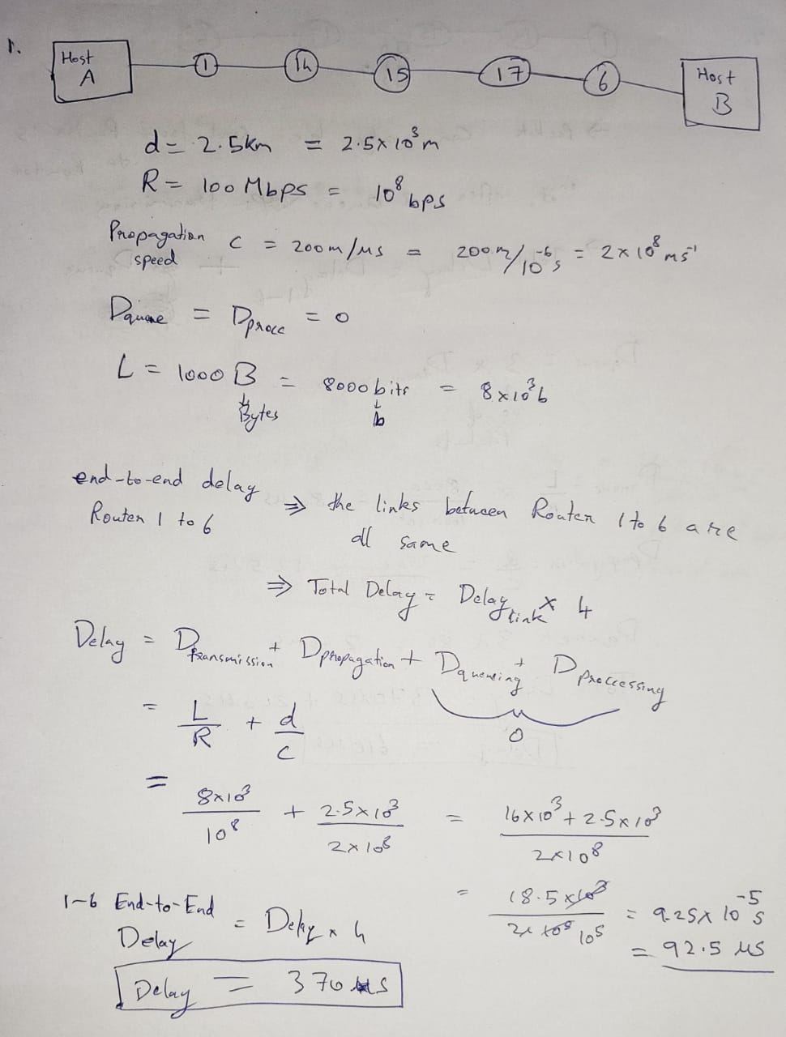
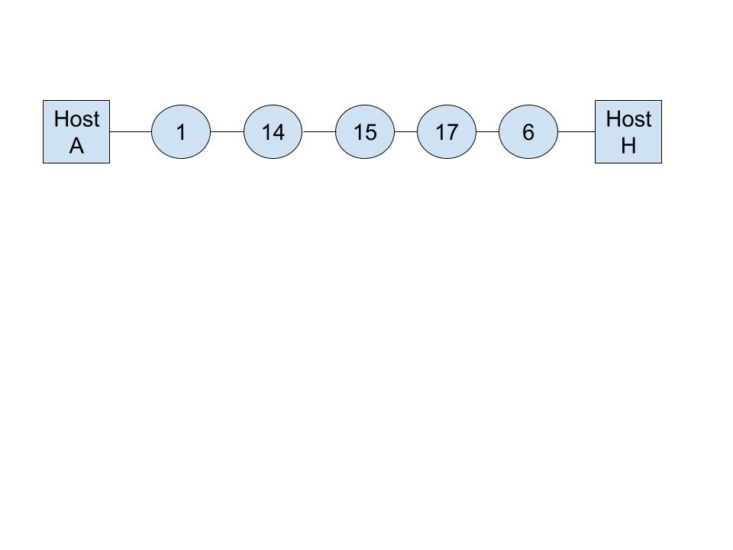

Assume the following:
all links are of distance d = 2.5km.
Capacity of the link R=100Mbps
Propagation speed s = 200m/microseconds
Queuing delay = Processing delay = 0
Packet size L = 1000 bytes

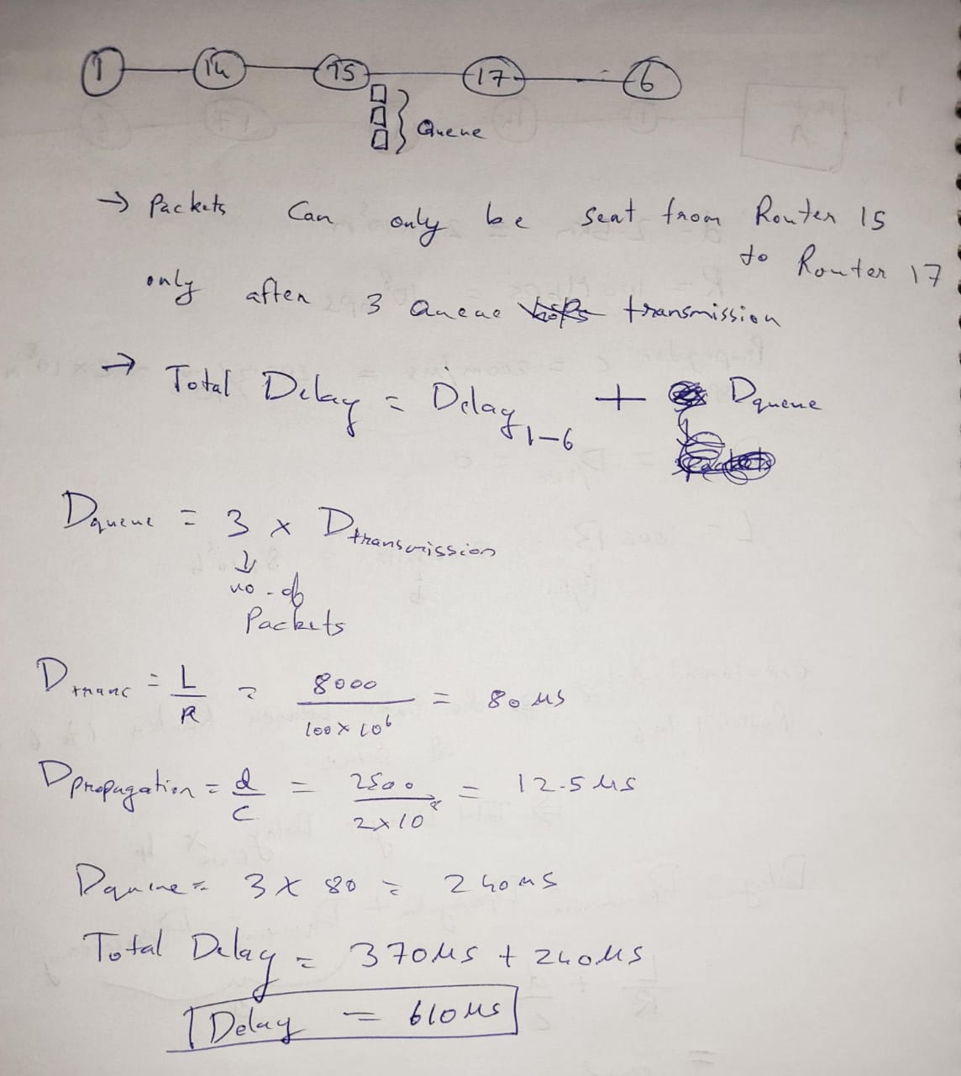
- What is the end-to-end packet delay in this store and forward subnet from router 1 to router 6, under the scenario that when a packet from router 1 arrives at router 15 there are 3 packets enqueued for the link to router 17?

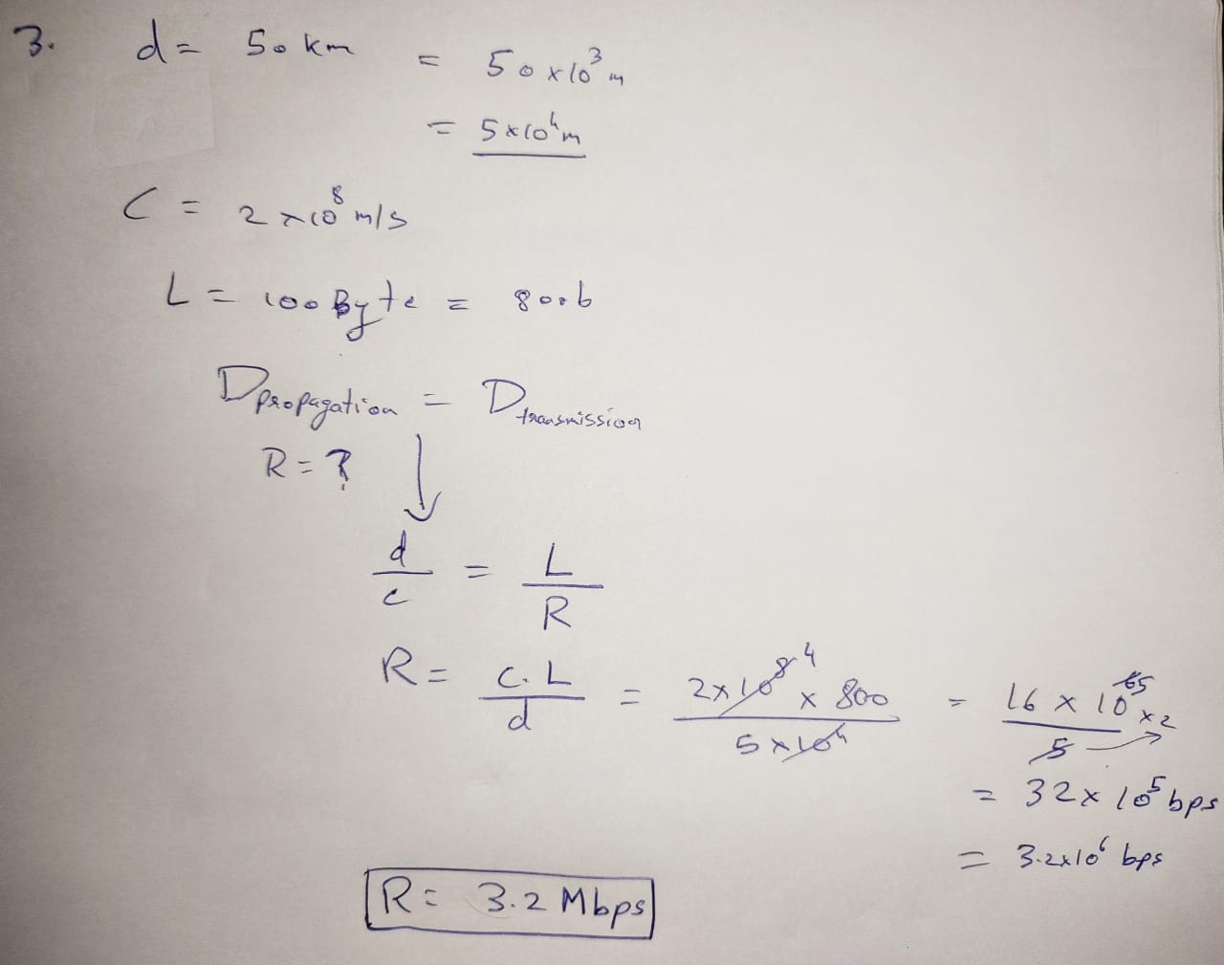
- Consider a point-to-point link 50 km in length. At what bandwidth would propagation delay (at a speed of 2 × 10^8 m/sec) equals transmit delay for 100-byte packets?

Part2 – Use Wireshark to view the traffic.
Capture and Analyze ICMP Data in Wireshark
Step1: Start capturing data on the active interface (wi-fi or Ethernet)
      - Start the data capture again.
      - A window prompts you to save the previously captured data before starting another capture. It is not necessary to save this data. Click Continue without Saving.
      - With the capture active, ping and tracert the following three website URLs from a Windows command prompt:
Open a Windows command prompt
        - Domain name specified in the interface you had connected to internet.
        - www.amrita.edu
Note: When you ping the URLs listed, notice that the Domain Name Server (DNS) translates the URL to an IP address. Note the IP address received for each URL.
      - You can stop capturing data by clicking the Stop Capture icon.

Examining and analyzing the data from the remote hosts.
Review the captured data in Wireshark and examine the IP addresses of the two locations that you pinged.

Questions:
IP address for am.studentds.amrita.edu: 192.168.0.252
How many Ping request and reply packets are captured?
Packets: Sent = 7, Received = 7.
Try to provide screenshots to show these details in the ICMP frames captured. Justify your answers.
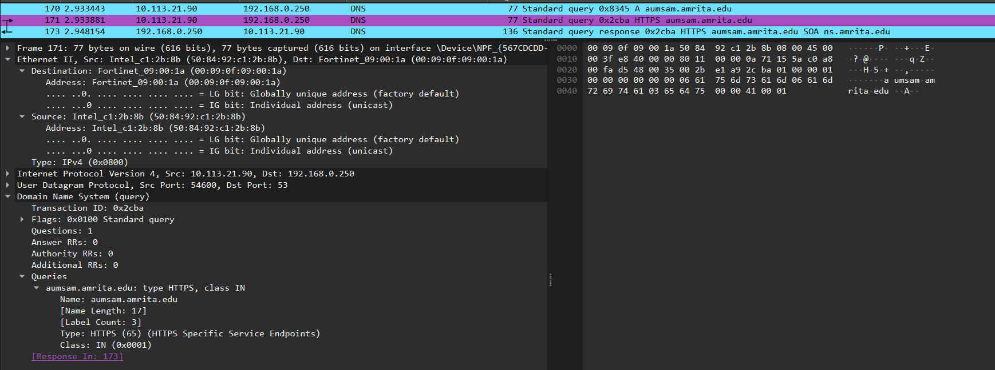
DNS request
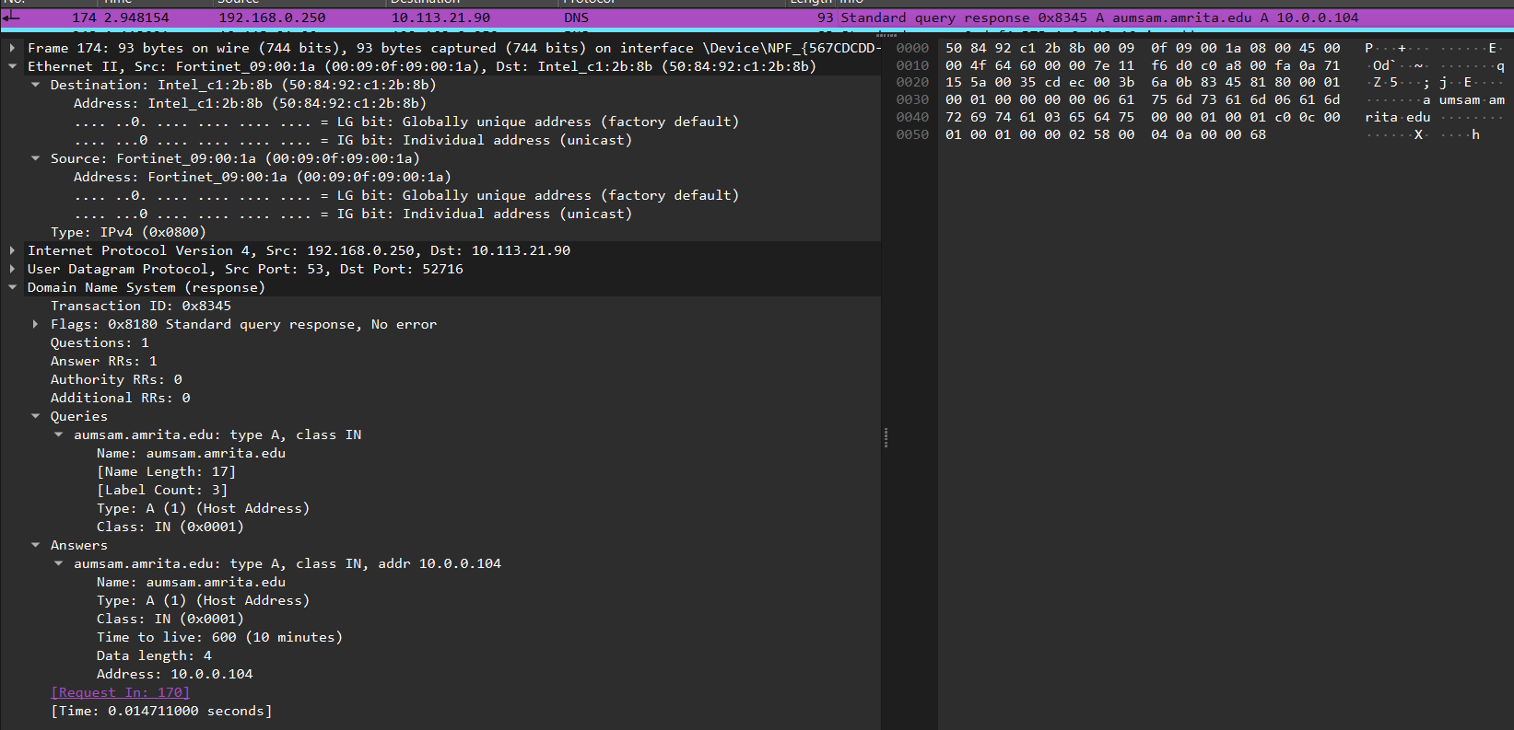
DNS Response
TCP 3 way handshake
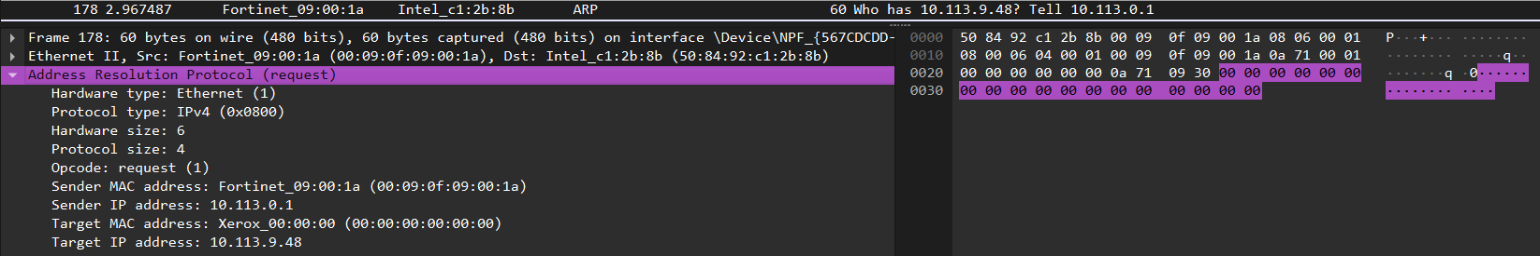
Address Resolution Protocol
Packet data captured
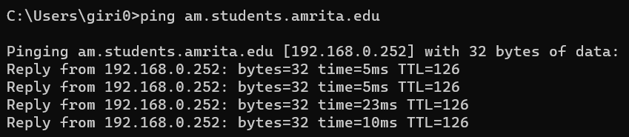
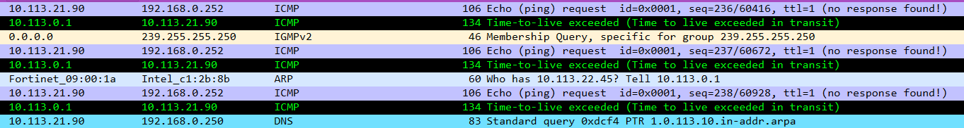
Ping Request and response
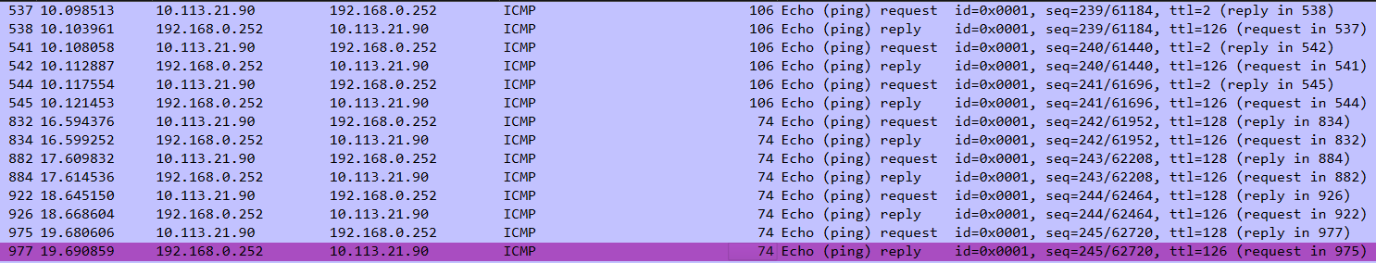
7 Request and 7 replies captured
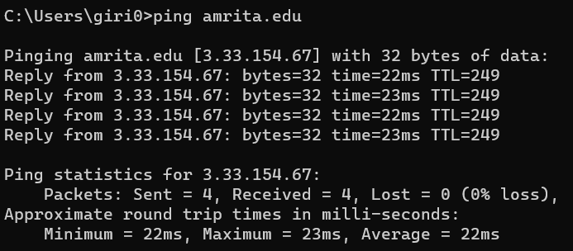
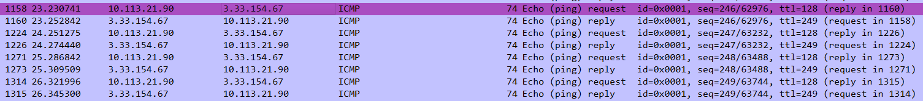
4 request and 4 replies captured
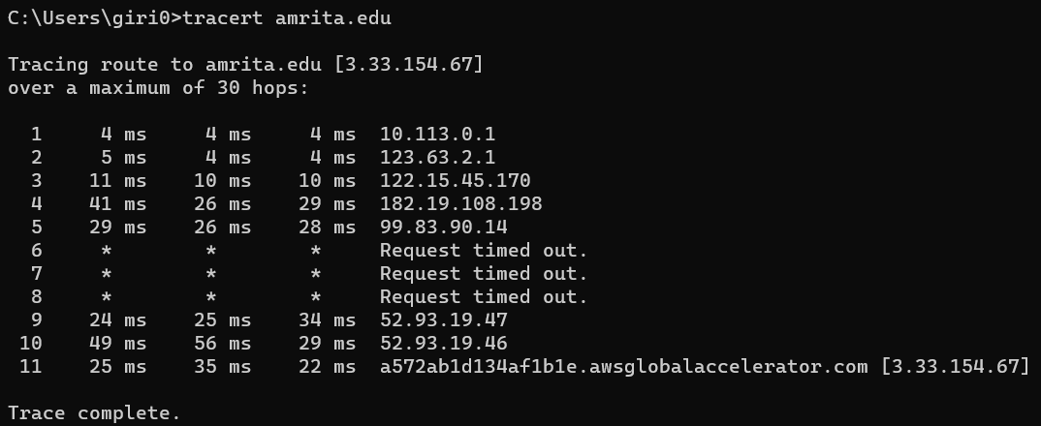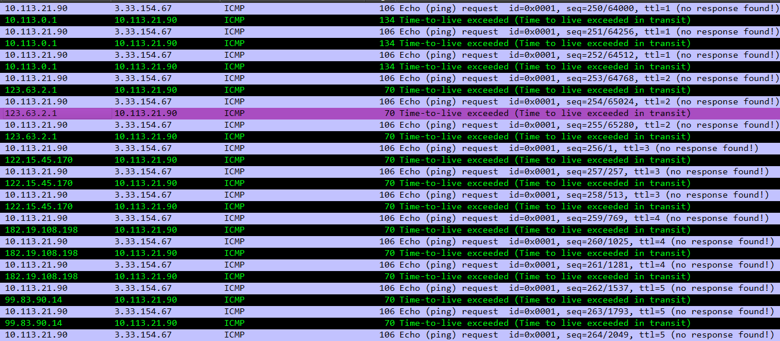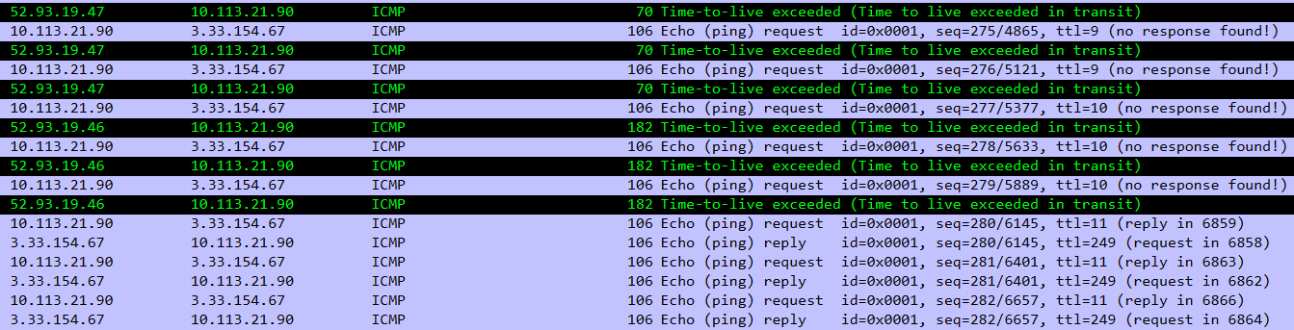
IP address for amrita.edu: 3.33.154.67
How many Ping request and reply packets are captured?
Packets: Sent = 4, Received = 4.

